Constitution day
Political science department
The students of the Department of Political Science, University of Ladakh celebrated Constitution Day on 26th November 2022, by organizing a speech competition on “The Constitution and its Various Aspects” among the students from various departments.
The Hon’ble Vice Chancellor, the University of Ladakh was the chief guest on the occasion.
The event began with the reading of the PREAMBLE. Participants spoke about various elements of the Indian constitution such as the Preamble, Role of Dr. B R Ambedkar in framing the constitution, Articles, constitutional Rights for women, schedules among various other topics. There were 3 judges Dr. Sonam Joldan, Dr. Tenzin Nakdon and Dr. Chimat Ladol.
The Prof. S.K. Mehta, the Chief Guest distributed the prizes to the winner.
Tsering Namgail (Mathematics), Stanzin Yangchen (Zoology), Tsering Chuskit (TTM) and Zahra Batool (History) received the prizes. Students of the political science department sung a patriotic song and the program concluded with the national anthem.
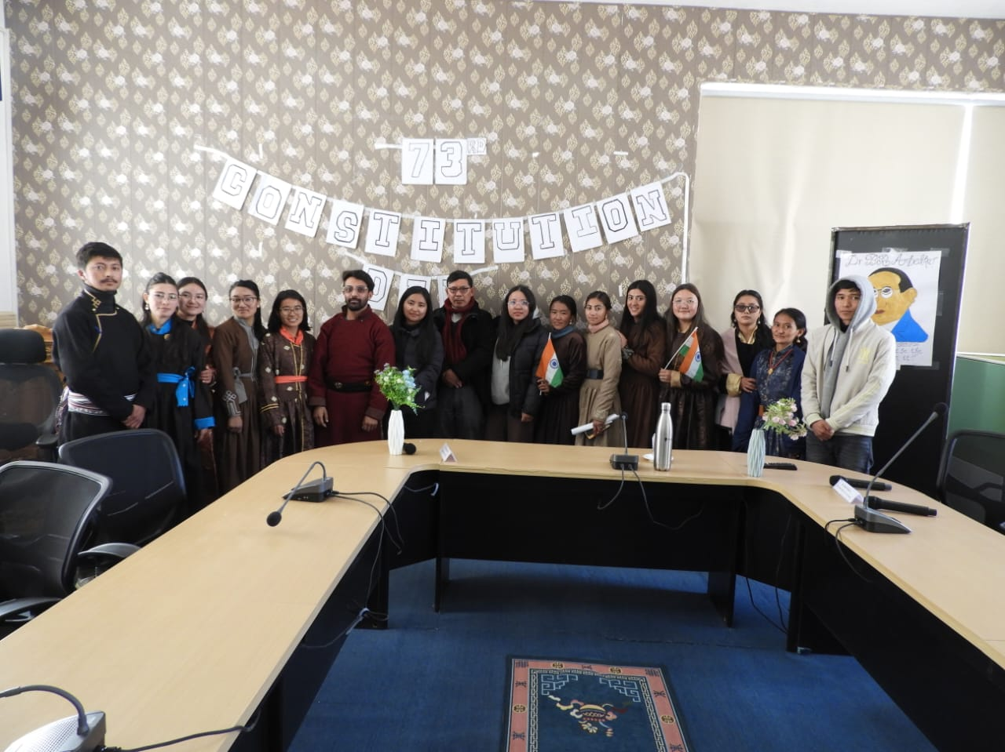
-sd-
Sonam Joldan

